Sonoma State University School of Education
READING AND LANGUAGE
GRADUATE HANDBOOK
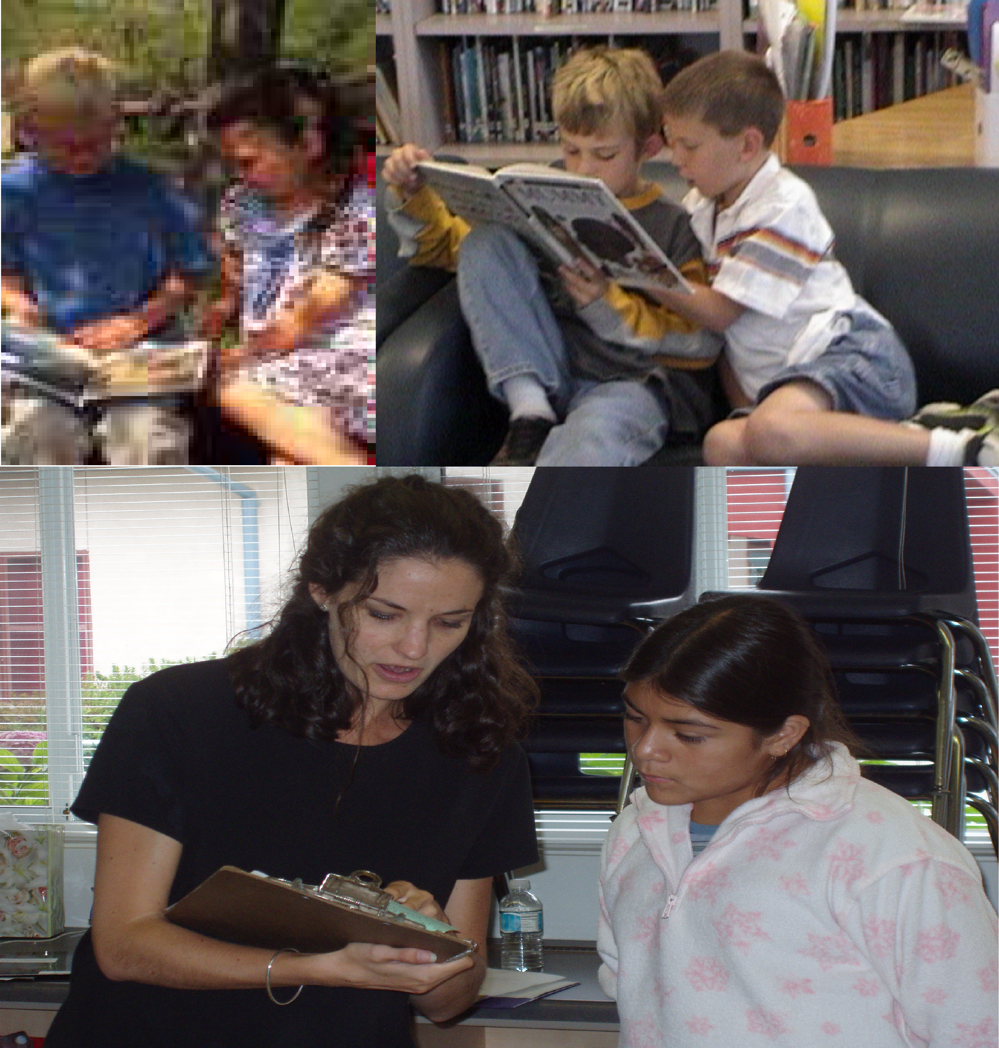

Sonoma State University
School of Education

Reading and Language Education Handbook

Table of Contents

Overview of the Reading and Language Program
- Why Earn an MA Degree and a Reading and Literacy Added Authorization
- Fieldwork
- Program Requirements
- Course Descriptions
- Advising
- Links to Application Information

A. OVERVIEW
The Department of Literacy Studies and Elementary Education (LSEE) offers graduate coursework to support in-depth exploration of language development, literacy learning, and teaching. These programs are dedicated to excellence in the preparation of teachers through on-going professional development in current, researched-based curriculum and assessment, bilingual/dual-language education, reading, writing, and language arts education including critical and new literacies. Graduate level coursework features hands-on experiences that are immediately applicable in today’s multilingual classrooms.
The Reading and Literacy Added Authorization, embedded within Reading and Language concentration within the MA (Education) is informed by current theory and research on literacy and language. We believe that all readers, writers, speakers, and listeners can become better, more successful users and consumers of literacy and language. Pushing beyond the perspective that literacy is limited to reading and writing, we support the development of multiliteracies and understand them to be essential for successful participation in the 21st Century (Cope & Kalantzis, 2000, 2015; New London Group, 1999.). We approach literacy and language instruction from the perspective that all teachers are teachers of literacy and language—regardless of content area expertise—and that all students have the right to develop high levels of literacies on both English and their home languages (Center for Applied Linguistics, 2016). We support the use of translanguaging (Garcia, Johnson, & Seltzer, 2017; Garcia & Kleyn, 2016) both as an asset and a pedagogy.

Aligning with the School of Education’s focus on social justice, RLAA Coursework examines literacy with a critical lens. Coursework embeds the four critical social practices of critical language study, interrogating multiple perspectives, focusing on the sociopolitical, and taking action within a larger instructional model of critical literacy (Lewison, Leland, & Harste, 2014).

Coursework addresses persistent problems and contemporary issues in literacy learning and teaching as well as professional inquiries posed by our students. Candidates will:
- Develop high-level skills in teaching and assessing beginning, struggling, and proficient readers of all ages
- Learn theoretically sound research-based practices for teaching all students
- Become a better prepared teacher, able to meet the demands of dynamic classroom settings
- Learn effective ways to work with colleagues and parents to design and carry out successful literacy programs
- Be in a position to become a district, county or school leader in learner-centered, standards-based language arts curriculum
- Learn supervision and staff development skills
- Better understand pedagogical and political issues in literacy
Many of our students earn the Reading and Literacy Added Authorization and a master’s degree simultaneously. It is designed with both full-time and part-time students in mind and is based on sound educational practice, current research knowledge, sensitivity to the needs of TK-12 education, appreciation for diversity, and respect for all learners. Part-time students generally enroll in 6 units (two courses) per semester. More specific details about the MA in Education Program can be found in the MA Handbook:
http://web.sonoma.edu/education/handbooks/MA_Handbook_rev_2019.pdf

B. WHY SHOULD I EARN A MASTER OF ARTS IN EDUCATION WITH THE READING AND LANGUAGE ADDED AUTHORIZATION?

Graduates of the School of Education MA Program have assumed a variety of positions in both education and business. Some of the positions have included the following:

- District reading coordinator
- Early intervention reading program coordinator
- Community college reading teacher
- Reading resource teacher
- Reading consultant
- University adjunct
- Private tutor
- County reading/language arts coordinator
- Education director for business company
- Textbook editor and reviewer
- Author of articles for professional journals

C. FIELDWORK
For the RLAA an observed practicum is required. The program ensures that candidates work at field sites where the instructional approaches and methods are consistent with a balanced, comprehensive program of reading and literacy instruction. Clinical fieldwork is conducted in the Summer Reading and Writing Academy. The Academy includes on-going guidance, assistance, and feedback by the professor and Academy Director to ensure that candidates demonstrate the knowledge and skills of an expert Reading and Literacy teacher.

Because the program holds that relevant, current and researched-based literacy curriculum and assessment must be practiced in the field with students, each course leading to the RLAA and MA degree require fieldwork. The amount of fieldwork varies in each class. Course instructors and syllabi specify the amount of fieldwork required. Candidates are encouraged to use their teaching contexts or to find classrooms that are open to graduate students observing and teaching literacy curriculum. Candidates’ work in classrooms must always be conducted with the tenets of the best practice for the students and as a learning experience for the graduate candidate. The instructional approaches and methods must be consistent with a balanced, comprehensive program of reading and literacy instruction.

In the Summer Reading and Literacy Academy, candidates evaluate the culture of literacy at a classroom, grade or school level, and identify how it supports or impedes students’ literacy development. Candidates use that information and current research and theories on reading and literacy development, including first and second language development, to develop a plan of action to strengthen the literacy skills of a group of public school learners to support their literacy learning.

Description of the Summer Reading and Writing Academy- EDRL 527A

- To enhance reading and writing for public school students from ages 7 through 15 in an authentic, student-centered program that is beneficial to both students & the graduate candidates
- To provide an opportunity for all aspects of professional development for Added Authorization candidates
- To provide an opportunity for Added Authorization candidates to co-organize and co-implement the Summer Academy in conjunction with university faculty
- To provide a supervised clinical field experience in literacy and language development for Added Authorization candidates
In order to be prepared for the Academy Experience, RLAA candidates will:

- Learn about reading and writing workshop formats
- Develop instructional plans for their assigned student groups
- Conduct language and literacy assessments
- Develop informed instruction
- Participate in student/parent conferences
- Collaborate and conduct student assessment sessions
- Report information and insights to students, parents and school

Location and Time Frame
The Academy is usually held in the Roseland District. We are grateful to the District for their support. We are will have students from others areas, schools and districts attend as well. The Academy is offered in a public school setting with a high cultural and linguistic diversity in order to better prepare advanced literacy teachers, leaders, and teacher supervisors. The Academy is often scheduled to occur in July for three weeks. This enables children enrolled in summer school to attend the Academy when summer school ends.

D. PROGRAM REQUIREMENTS

The School of Education offers two options in Reading and Language:
- Reading and Literacy Added Authorization (RLAA)—15 units of coursework*
- Master of Arts in Education with a concentration in Reading and Language—30-36 units
*All courses in the state-approved RLAA may be applied to the MA degree.

The Reading and Literacy Added Authorization (RLAA)
The RLAA prepares individuals to take a literacy leadership role at the school site and emphasizes working with students who experience difficulties with reading. Many teachers with the RLAA choose to stay in their own self-contained classrooms; others may become literacy curriculum coordinators or PLC leads. They may support other classroom teachers, assess student progress, and monitor student achievement while providing instruction and intervention. They also play a consultative role in materials and program selection at the district and may take leadership responsibility within the realm of the school site.

Program Prerequisite: A preliminary teaching credential is required for admission if you want to pursue the Added Authorization. A teaching credential is not required for admission to the concentration in Reading and Language otherwise. Three years of teaching experience is required to file with the Commission on Teacher Credentialing for the Added Authorization, but you do not have to have completed the three years to begin the program.

Program Coursework:

Developing a personal and professional model of literacy
The graduate courses in reading and language enable candidates to deepen their professional knowledge in literacy with a focus on multi-modal literacies grounded in researched-based literacy approaches, assessment, and the foundational and current research in the field.

Fall Only
Candidates develop a comprehensive set of strategies for promoting fluent reading and comprehension, planning and delivery of literature-based reading curriculum, and assessment-based intervention and instruction. Candidates also explore the research and practices in multi-modal literacies.

EDCT 552: Educational Technology Praxis (3 units)
EDRL: 524 Literature and Literacy (3 units)
Spring Only
Students take part in an integrated investigation of literacy research/ theories/ beliefs/ practices aimed at developing a working understanding and reflective stance for each of these themes through in-depth case studies of emergent bilinguals, struggling readers/writers. The breadth and depth of the themes ensure that candidates examine and understand the nature of fluent reading and comprehension, assessment approaches, planning and delivery of reading intervention and instruction, and best practices in assisting classroom teachers of native English speakers as emergent bilinguals. Focused field experiences and assessment that lead to purposeful reading instruction permeate these courses.

EDRL 521A: Language Development in First and Second Languages (3 units)
EDRL 522: Assessment and Teaching in Reading and Language Arts (3 units)

Summer Only

SSU Students participate in a Summer Field Experience and Clinical Practice (see Fieldwork Section B) providing them with the opportunity to implement the theory and research learned in fall and spring courses into practice with elementary-aged students. The course experience for graduate students, who serve as the teachers in the Academy, is focused on practicing and improving learner-centered reading and writing instruction They assess a wide variety of students, create and deliver standards-based instruction, work with other teachers, and reflect upon their own practice. This Summer Field Experience and Clinical Practice is attended by tk-6th grade public school students from the Roseland School District.

EDRL 527A: The Summer Reading and Writing Academy--Clinical Field Experience in Reading and Language Arts (3 units)

The Masters of Arts in Education with a concentration in Reading and Language
The Reading and Language concentration is designed to prepare teachers Pre K-Community College and/or professionals for specialized teaching of reading, language arts, curriculum and instructional leadership in the field of language and literacy. The program has an emphasis in bilingual learning and teaching theoretically-sound literacy to all learners. Required course work focuses on the nature of literacy development and the improvement of classroom curriculum, and methods that emphasize the relationship of literacy development to all learning. A Master of Arts degree with a concentration in Reading and Language is valuable to all content area teachers, as well as to educators from pre-K to Community College levels.

Program Coursework (30-36 units)

Reading/Language Core Courses (15 units)
EDRL 521A: Language Development in First and Second Languages (3 units)
EDRL 522: Assessment and Teaching in Reading and Language Arts (3 units)
EDRL 524: Literature and Literacy (3 units)
EDCT: 552: Educational Technology Praxis (3 units)
EDRL 527A: The Summer Reading and Writing Academy--Clinical Field Experience in Reading and Language Arts (3 units)
Education Core Courses (9-12 units depending on pathway to completion)
EDUC 570: The Reflective Educator (3 units)
EDUC 571: Research Paradigms in Education (3 units)
EDUC 598 and EDUC 599: Developing a Thesis and Supervised Study (6 units)
OR
EDUC 572: Developing a Cognate Project (3 units)

Supporting Courses
The MA with a concentration in Reading and Language education allows you to take 9 – 12 elective units depending on the pathway to completion of the degree. These courses can be in any approved areas, such as in curriculum, special education, educational leadership, early childhood studies or educational technology. Your advisor can help you decide which courses will fit your professional and academic goals.

E. COURSE DESCRIPTIONS OF READING AND LANGUAGE COURSES

EDRL 521A: Language Development in First and Second Languages (spring semester of odd numbered years)

Research and theory in oral and written language development in first and subsequent languages, and the relationship between literacy learning and teaching with special attention to factors that promote concept development and confident and effective language use in the target language. Attention to the structure of the English language and transferability between L1 and L2. Contributions from many fields (e.g., psycholinguistics, sociolinguistics, anthropology, and developmental psychology) provide perspectives for analysis of language acquisition and development and learning, evaluation of current educational practice, and planning for effective classroom experiences. Transfer strategies from primary language literacy skills into target language literacy skills are presented based on the tenets of effective language acquisition.

EDRL 522: Assessment and Teaching in Reading and Language Arts (spring semester of even numbered years)
This course is designed to provide classroom teachers and reading specialists with an understanding of the general and specific concepts related to reading assessment, as well as an understanding of how to conduct in-depth reading diagnoses, develop reading strengths, and address reading weaknesses. Students will learn to administer and interpret formal, informal, and curriculum embedded assessment measures. Students will reflect upon the theory they are reading and discussing regarding assessment procedures and then use various tools in practical applications. As a culminating experience, students will conduct an in-depth reading diagnosis of an individual student at a preK-12 school site who is experiencing reading difficulty and consider the implications of the results to recommend classroom instruction and clinical interventions. Reports will be presented to classroom teachers, principals, and parents.

EDCT 552: Educational Technology Praxis (fall semester of even numbered years)
Educational Technology Praxis requires students to take a reflexive stance towards the initiation and integration of technological skills and knowledge in authentic instructional contexts and settings. The practical application of technology will be grounded in current perspectives and trends in new literacies and new media technologies and take into account educational frameworks of learning, design, and pedagogical practice.

EDRL 524: Literature and Literacy (fall semesters of odd numbered years)
This course is a study of literature and multimedia texts for children and adolescents and their relationship to language and literacy practices, i.e. reading, writing, listening, speaking, and viewing. Students in this course will explore and demonstrate their ability to incorporate texts (including but not limited to traditional print texts, digital media, primary documents, visual images, and other creative work) into existing curricula as well as to design dynamic and relevant instruction to meet the specific needs of the diverse learners in their classroom or community context. Through the review of existing scholarship and the creation of original research, students will explore and begin to formulate definitions of a culture of literacy, with attention to bilingual and biliterate spaces. This will include a close look at literacy both in the traditional sense of the reading of printed texts and in the wider sense of multi-literacies, which include social and cultural literacies as well as new media literacies. Students will discuss literature as a way of knowing, and gain strategies for fostering learners’ engagement, motivation, and positive relationships with (bi)literacy practices through text selection, mentor texts, reader response, and critical literacy. In this course students will explore the role that literature and multimedia texts can play in the acquisition and teaching of literacy and biliteracy for all learners. Students will experience and discuss many texts, and consider their perspectives as (bi)literate individuals and as educators. Topics include critical literacy, the use of mentor texts for writing instruction, graphic novels and graphica, selection and censorship of classroom materials, fluency, reader response, genre (text structure and story grammar), online texts and resources, and high interest/good fit books, as well as comprehensible selections for struggling or striving learners, English learners/emergent bilinguals, learners identified as gifted and talented, and learners with special needs. Students will also create their own print and digital texts to record and share their research, book reviews, and reflections on their own identities and experiences as (bi)literate individuals.

EDRL 527A: Clinical Field Experience in Reading and Language Arts (summer of even numbered years)
EDRL 527A (3-6 Units) is a supervised practicum for Reading and Literacy Added candidates. In a Reading and Writing Workshop format, candidates work with students K-12 under the supervision of and in collaboration with clinical faculty and Reading and Language Arts Specialist Credential candidates. Certificate candidates are assigned to students based on the candidate’s prior program coursework and professional background, in order to assure diversity of experience with readers and writers of varying ages and abilities. Certificate candidates conduct formal and informal assessments and plan instruction and intervention for students in the clinic. Based on assessment findings, candidates collaborate in the delivery of appropriate instruction and interventions that utilize learners’ strengths in order to address their needs. Candidates participate in clinical conferences and write reports in which they summarize and critique assessment findings and the success of the instruction. Opportunities will be available for candidates to work with beginning readers, struggling readers at different levels, English language learners, and successful readers and writers

F. PROGRAM ADVISING
Candidates are advised throughout the program to ensure that the course sequence is appropriate for meeting individual student needs. Program Planners help guide candidates to the specific coursework requirements for each credential pathway. Candidates participate in periodic advising sessions throughout the reading and language graduate program.

Advising meetings are scheduled when the candidate is admitted to the program, through the program, and when the candidate is completing the program and their Advancement to Candidacy and Thesis/Cognate Presentation. It is the candidate’s responsibility to seek help or advice if confused about program requirements or scheduling of courses.

- Orientation / Advising Meeting: When candidates receive their acceptance letter, they should contact the Reading advisor to set up an appointment for initial advising.
- Advising Sessions: Each semester, candidates should contact the Reading advisor for further advising about courses being offered and how to stay on track.
- Individual Advising: If a candidate has program and/or advising questions that are not answered during the regular advising sessions, please the Graduate Reading Advisor for an appointment.

G. APPLYING TO THE PROGRAM
There are two applications processes, to the University and to the School of Education. You may apply to begin in either the fall or the spring. The School of Education website has up to date information about the deadlines and the process. If you have questions, please contact the advisor for the Reading and Language Concentration or the Director of Graduate Studies for the School of Education. These names and emails are listed on the School of Education website.

Link for applying to the university:
https://www2.calstate.edu/apply

Link for information on School of Education programs:
http://web.sonoma.edu/education/programs/index.html

